DES Algorithm
-Zishan Kazi, Keshav Bansal

Introduction

Data Encryption Standard is a symmetric-key algorithm for the encrypting the data. It comes under block cipher algorithm.

In the code, we take plain-text (string) and convert into bitstream (64 bits).
Every time we take 64 bits from that and give as input to DES algorithm, which is then processed through 16 rounds and then converted to cipher text.

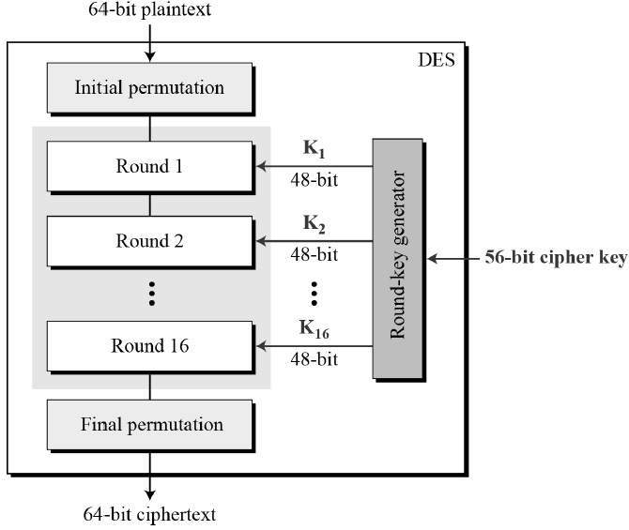
Implementation

Initial permutation

When the string is converted into 64-bits then it is send to initial permutation where we change the position of the bits according to the matrix initial_permutation[64] which we have defined in the code.

Round 1

After initial permutation, it is sent to round 1 which has its own set of 48-bit key. After which it is simlarly sent to 15 more similar rounds (16 in total) which have their own set of keys. Each round can be shown with the following diagram:

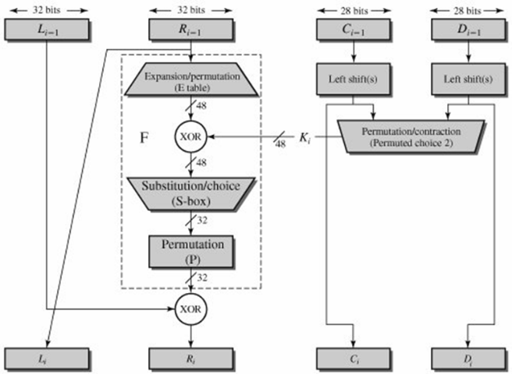

The L[i-1] and R[i-1] are the left half and right half of 64-bit stream sent after initial permutation.

Expansion of R[i-1] from 32 bits to 48 bits takes place so as to XOR with 48-bit key, which is then sent to 8 S-boxes each with 6 bit each.

The right side in the diagram consists of key generation which can be explained in detail in the following diagram:

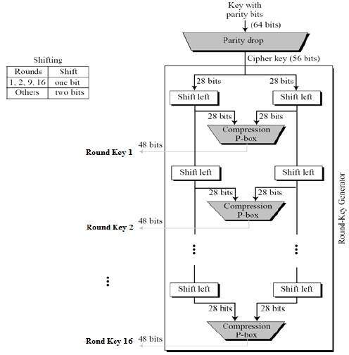

Key generation

We have 1x64 matrix Original_key[64], which is converted into 56-bit

